Track Model User’s Manual

1. User Inputs
   1. Inputting Track Configuration

To input a track file type the file name in the Track Input File section and hit the Update Track Button.

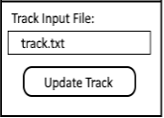The Track Input File Section is shown below.

* 1. Force Majeure Inputs

To enter in a force majeure input the user should click in the box next to the type of force majeure they wish to enter into the model.

Once the box is clicked a cursor will appear and the user can type in the number of the block they wish the force majeure to occur in.

To confirm a force majeure input click the button labeled with the type of force majeure input they want.

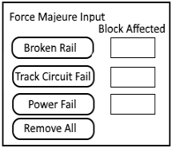To remove all force majeure inputs from the model the user should click the Remove All button at the bottom of the force majeure section.

* 1. Outside Temperature Input

To set the outside temperature for the whole system type in the desired temperature in Fahrenheit in the box in the Temperature Set Section.

1. 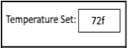System Inputs
   1. Inputs from Wayside

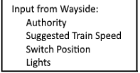The Track Model UI displays the values it receives from the track model in the Inputs section depicted below. It receives the Authority, Suggested Speed, Light coloring and Switch Position from the Wayside.

* 1. Inputs from Train Model

The input from the train model is its current velocity. This value is used to determine the current position of the train on the track. This is depicted below.

1. Outputs
   1. Output to Wayside

The output to the wayside controller consists of which blocks are currently occupied. This information is displayed in the Outputs section

* 1. Output to Trains

The output to each train consists of:

1. Speed limit
2. Current grade
3. Outdoor temperature
4. Authority
5. Track heater status
6. Whether there is a station next block
7. What side the next station is on

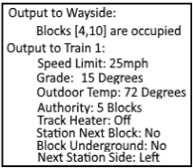A depiction of the outputs section is shown below

1. System State

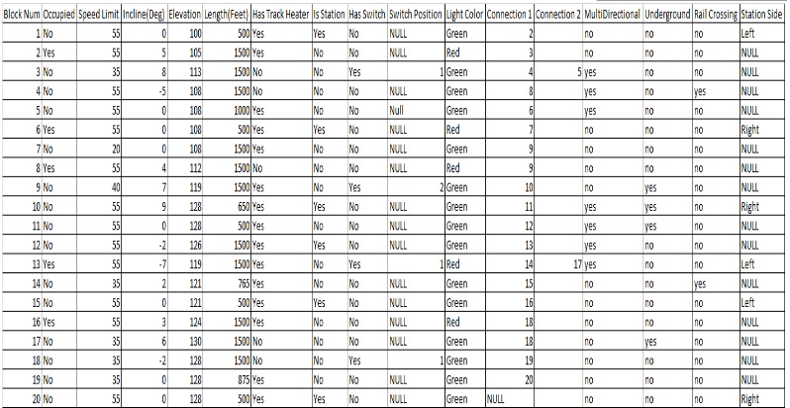The total track system state is shown in the bottom half of the screen. This depicts static values like grade and length as well as dynamic values like switch position and light color.